

**Submitted by: Submitted to:**

**NAME: Rahul Gusain Hitesh Kumar Sharma**   
 **SAP: 500084143**  
 **ROLL NO.: R214220900**  
 **BATCH: 1 DevOps**

EXPERIMENT 4

**AIM: Working with Docker (Basic Commands)**

**Steps to Complete:**

Step 1 -Create Network

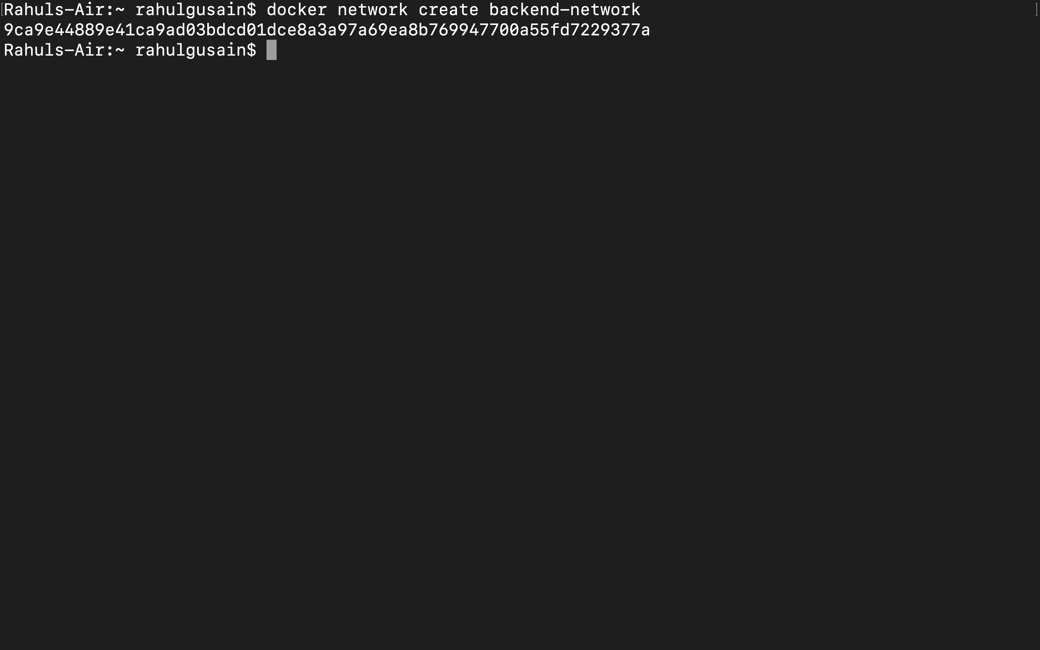

Connect To Network

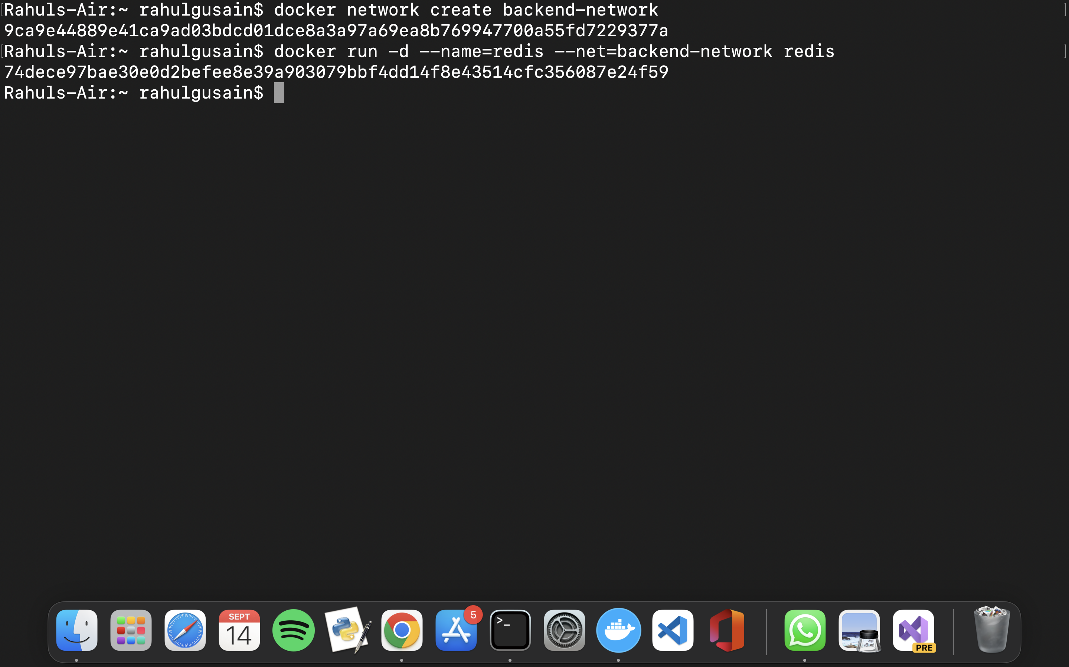

Step 2 -Network Communication

Explore

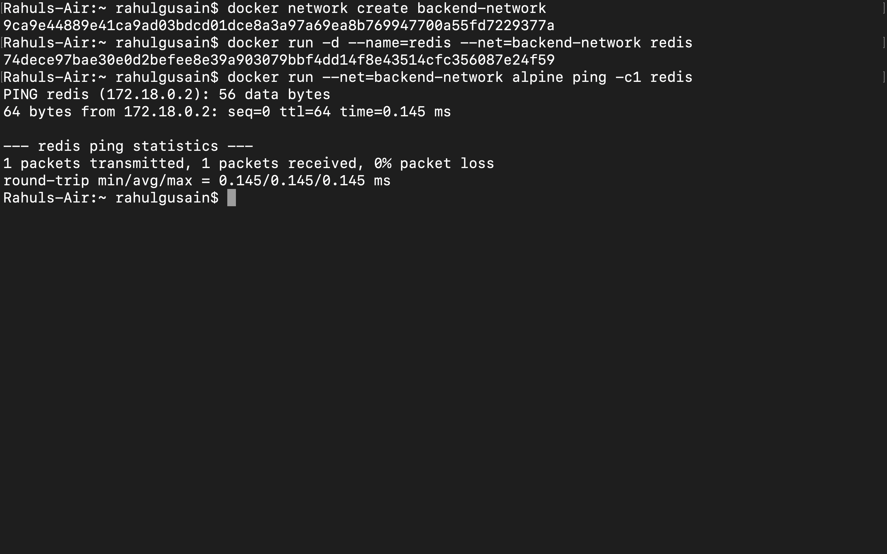

Step 3 -Connect Two Containers

The first task is to create a new network in the same way.

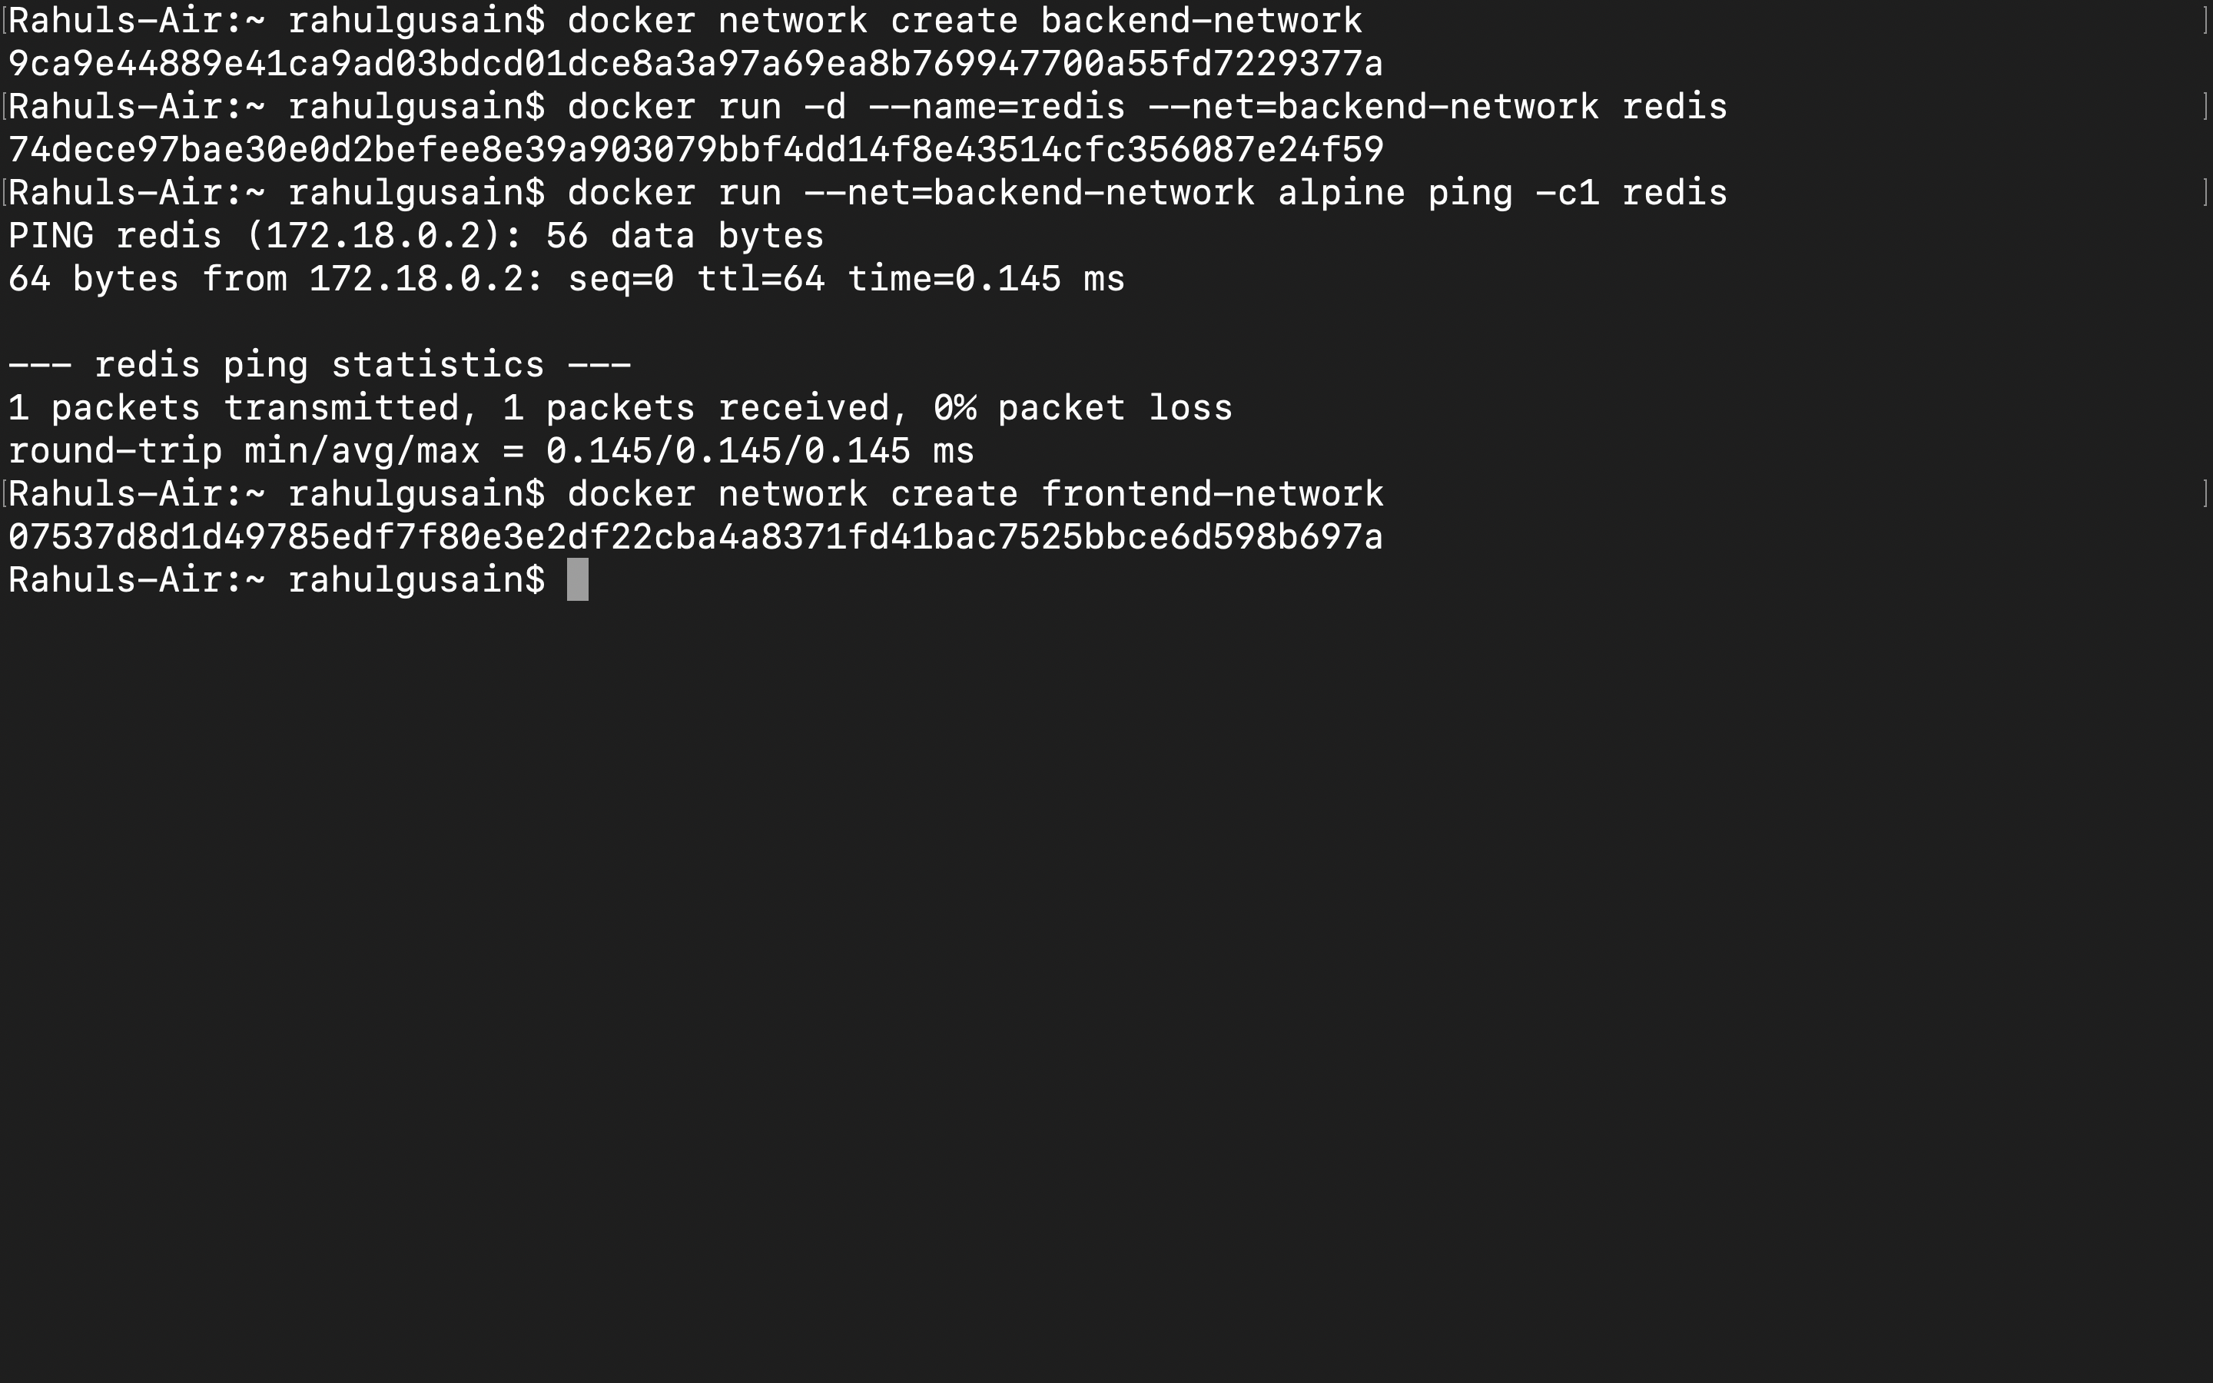

When using the connect command it is possible to attach existing containers to the network.

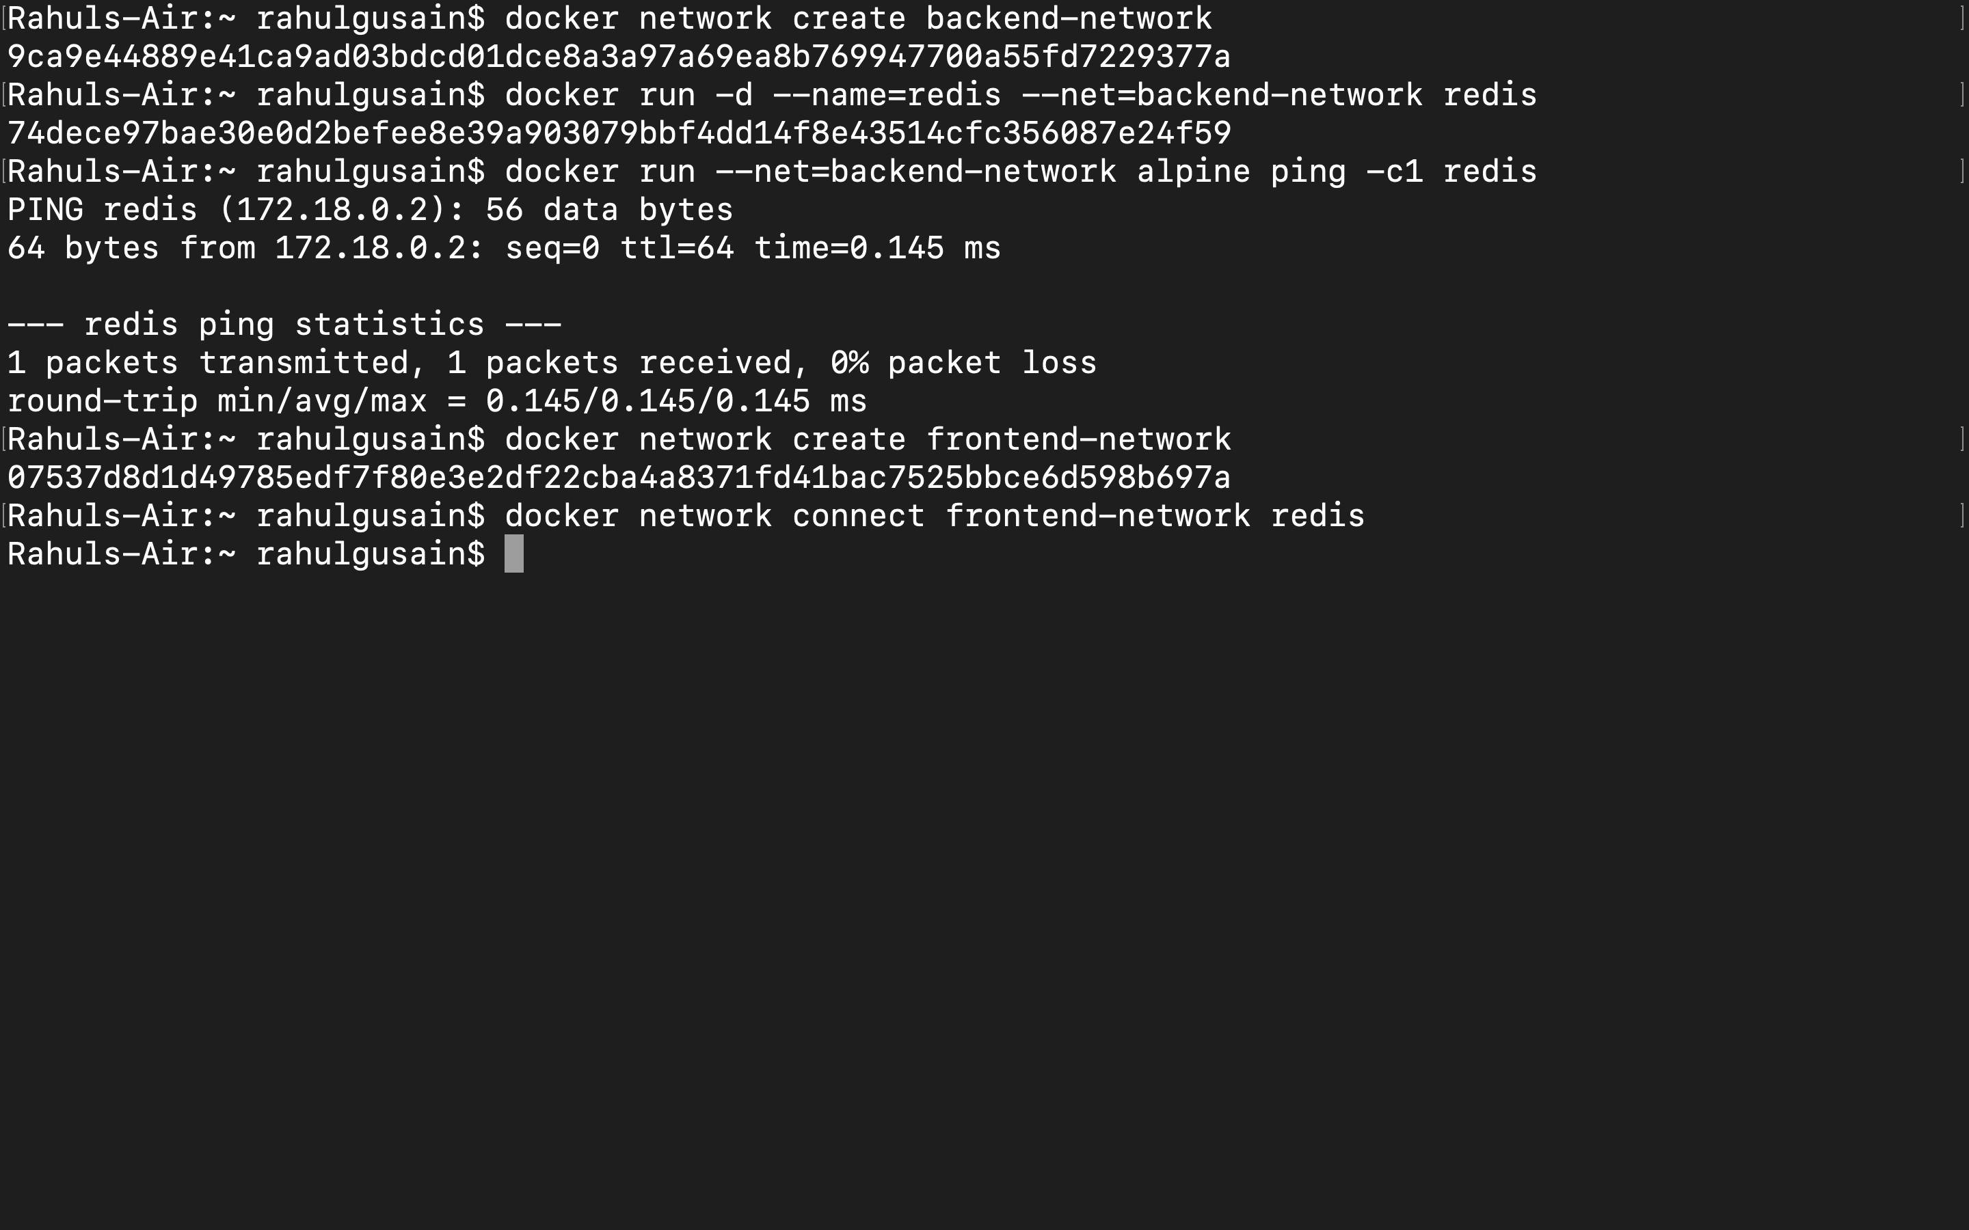

When we launch the web server, given it's attached to the same network it will be able to communicate with our Redis instance.

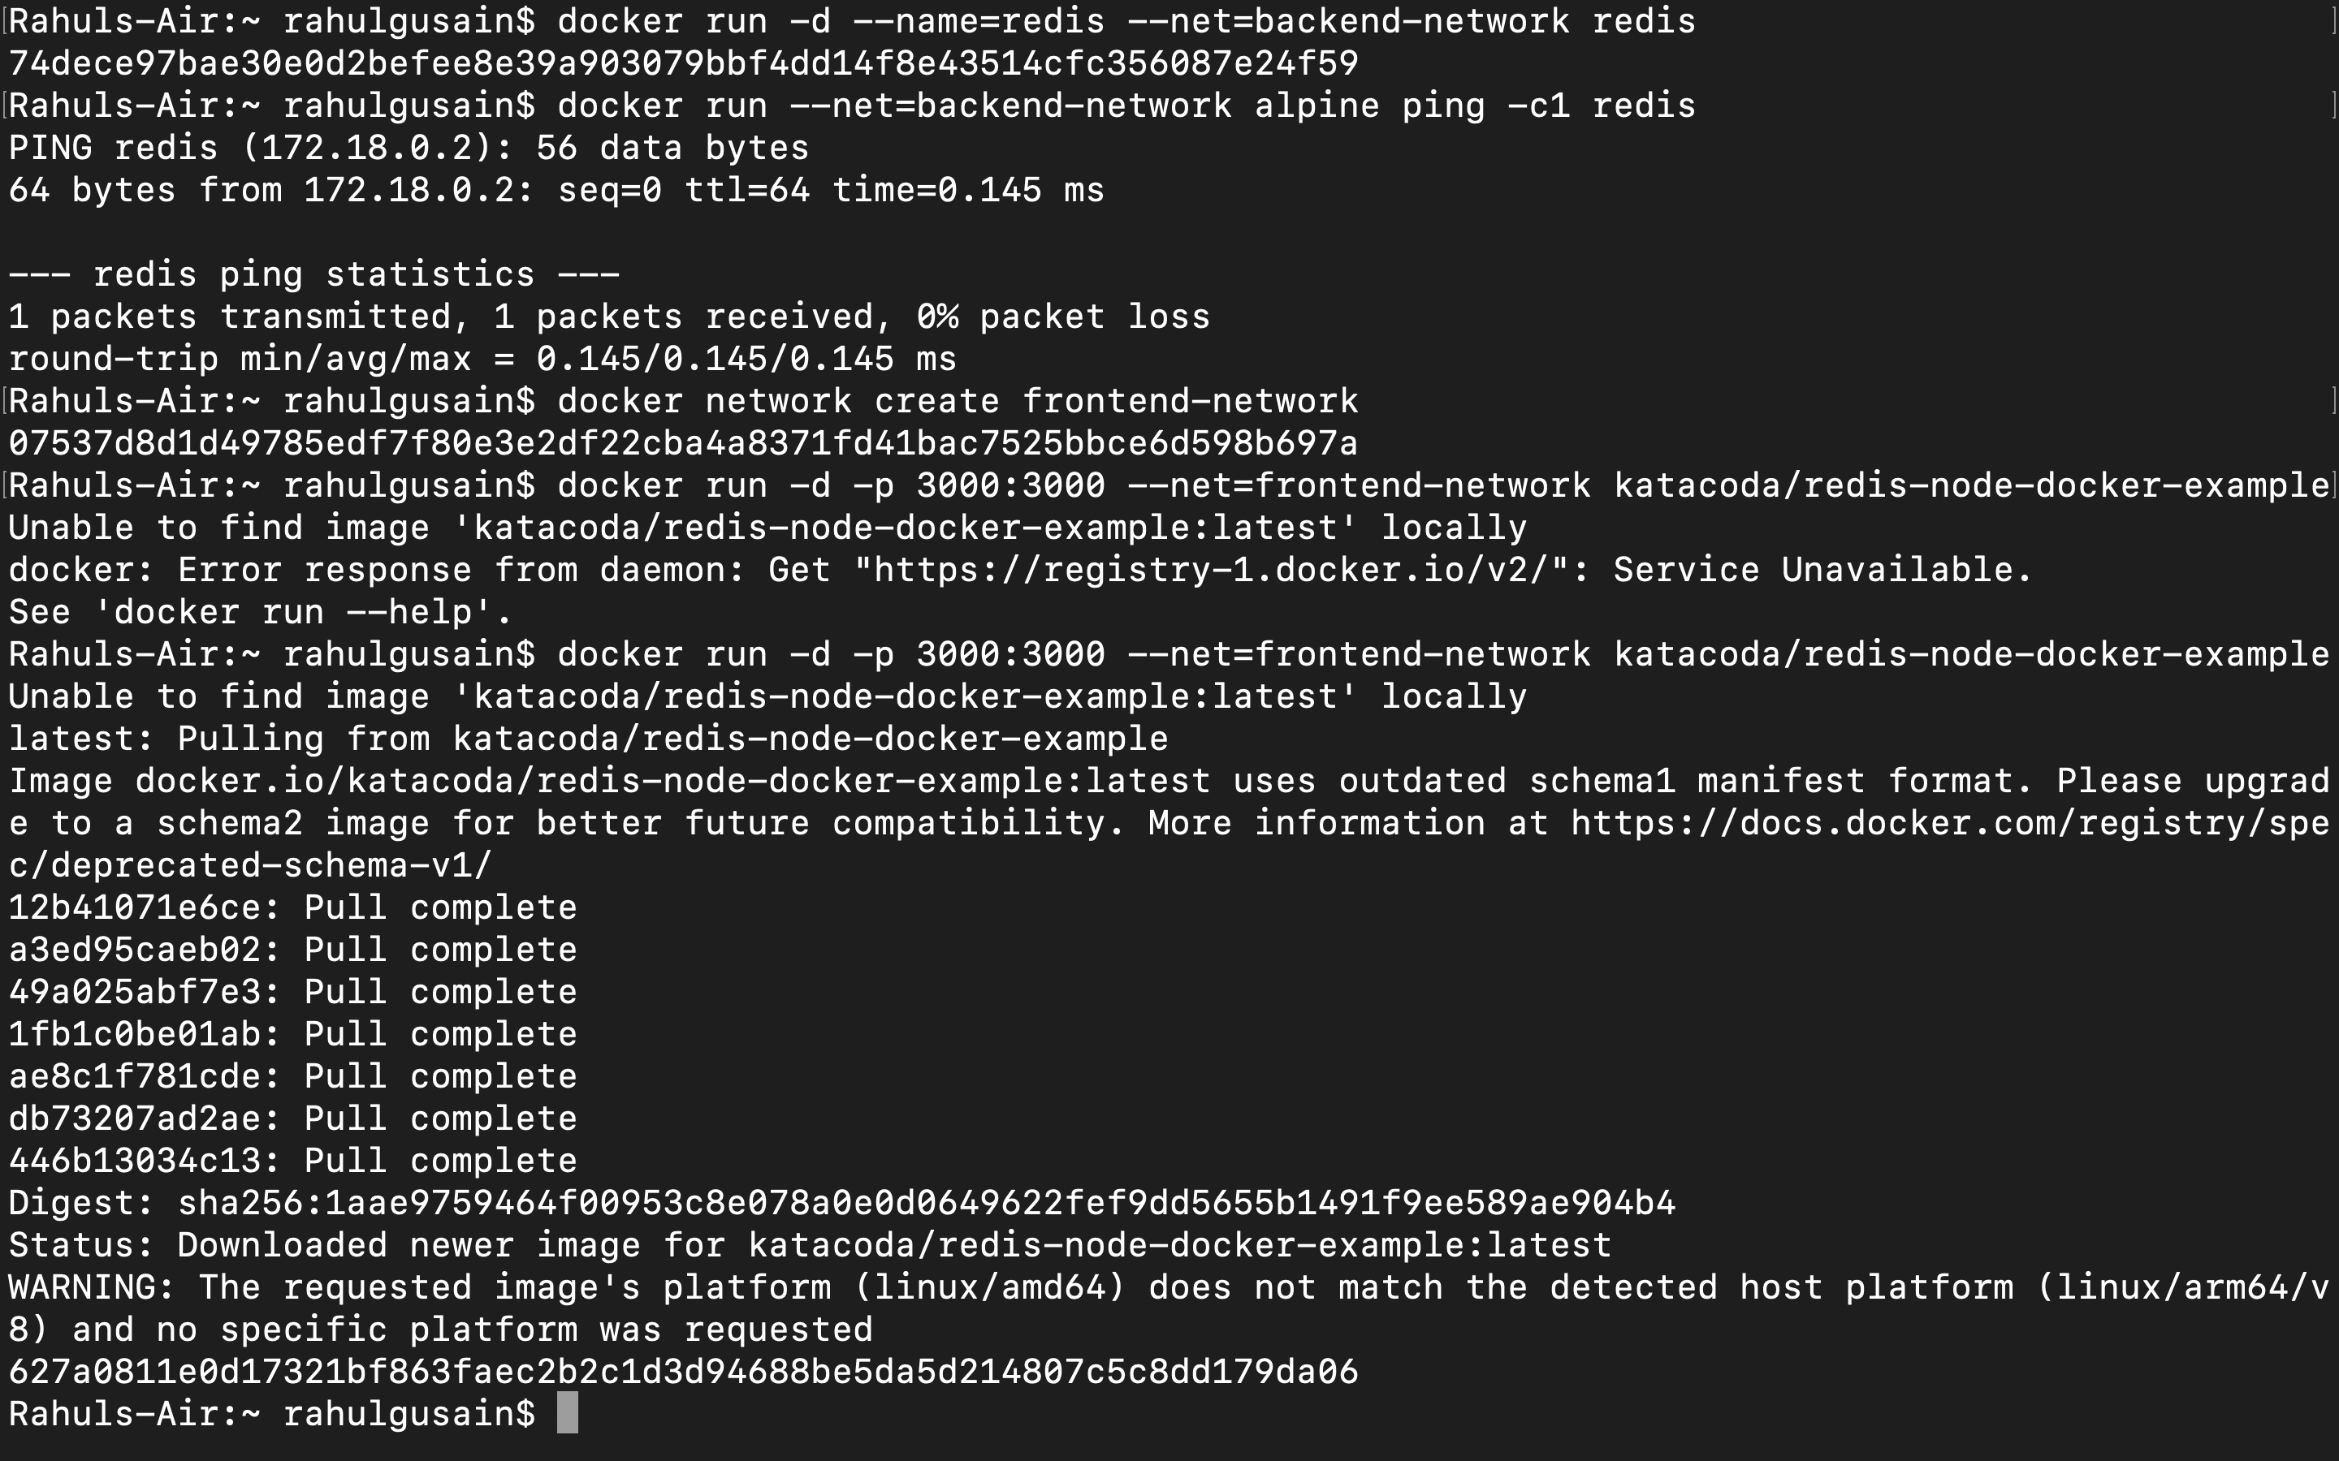

Step 4 -Create Aliases

Connect Container with Alias

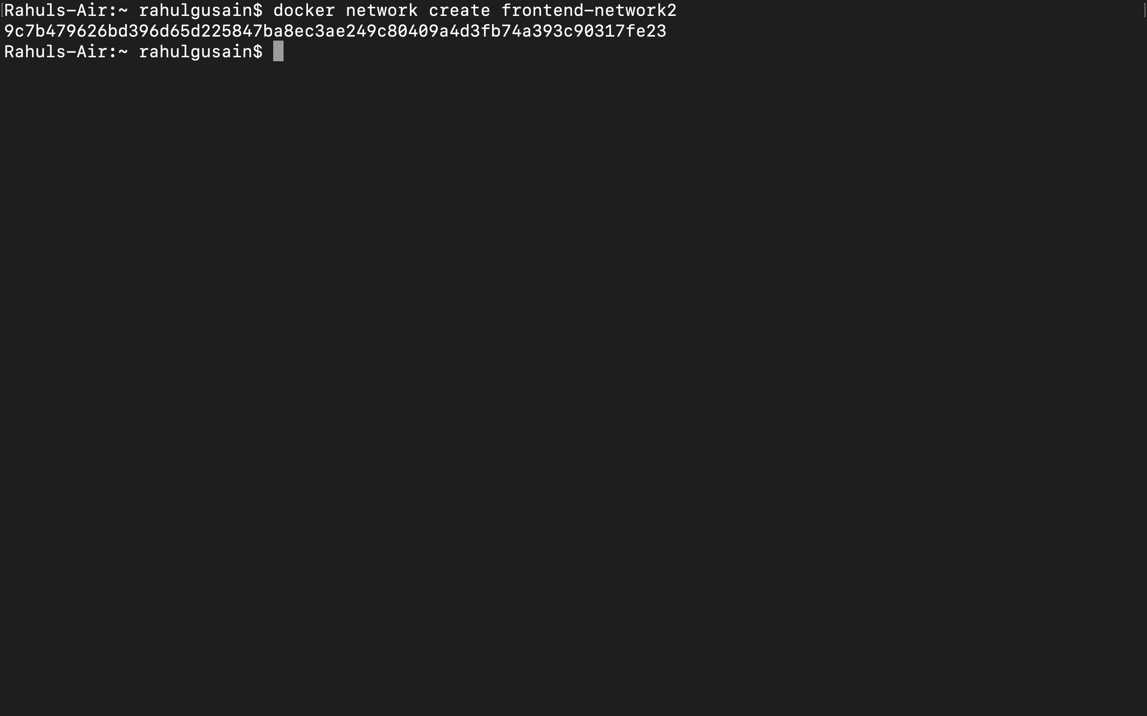

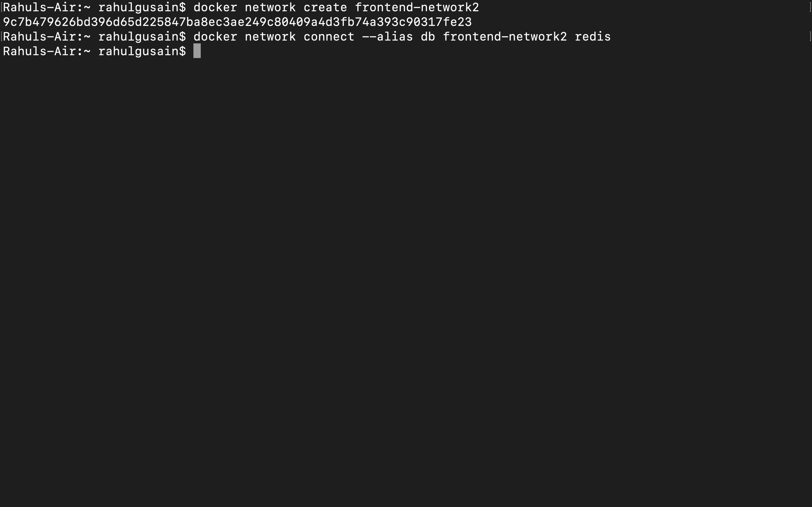

When containers attempt to access a service via the name db, they will be given the IP address of our Redis container.

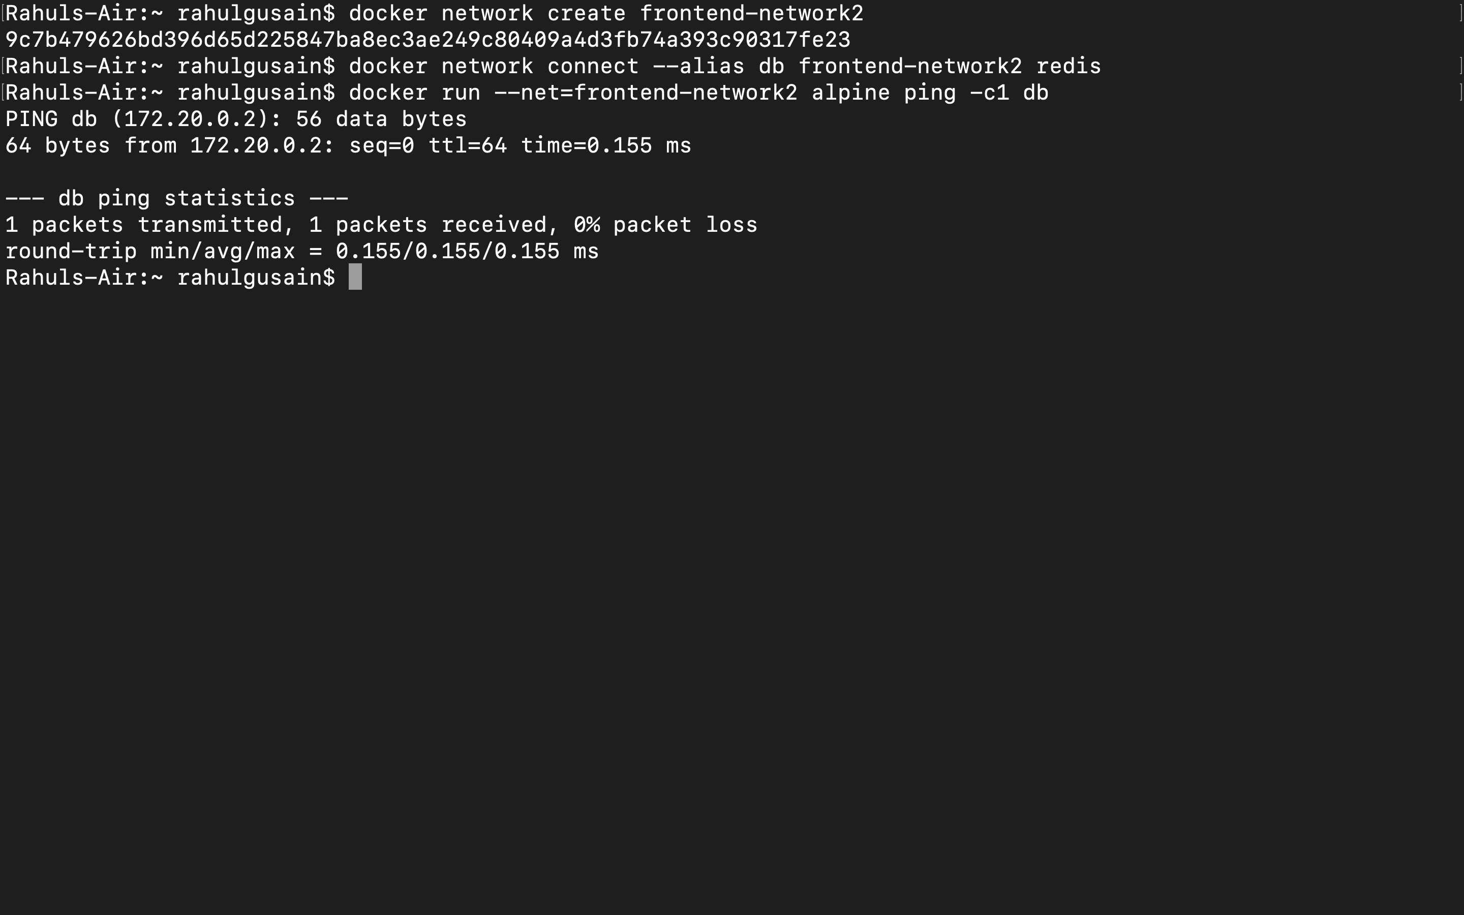

Step 5 -Disconnect Containers

